Ottawa home & garden show

Visit www.ottawahomeandgardenshow.com for more details.

Please find enclosed your complimentary VIP tickets to Ottawa’s largest and most exciting home and garden event. Avoid the crowds and see the show the way YOU want via the RE/MAX VIP entrance. Beat the line at the Bonneville Model Home and enjoy prime seating in both the Perth Brewery Beer Gardens and at the main stage. Whether you’re buying, selling or renting a home, the RE/MAX VIP experience at the Ottawa Home + Garden Show will help you source everything you need to improve your space and maximize your return on investment.
From paint colour to furniture, landscaping to functionality, your space is all about you. Do the homework to make your home work at the Ottawa Home + Garden Show presented by RE/MAX, returning March 21-25, 2019 at the EY Centre. Check out must-see features and more than 300 trusted brands.

RE/MAX VIP benefits include:
- Exclusive access to the RE/MAX VIP entrance leading directly into the Living Landscapes Garden Feature. (Other visitors will have to visit the entire show before entering the feature)
- Front of the line access to the Bonneville Model Home Feature
- Front row seating at the stage for presentations.
- Designated VIP seating area at the Living Landscapes Beer Gardens
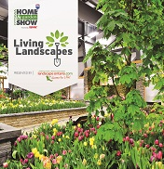
THE LIVING LANDSCAPES BY LANDSCAPE ONTARIO
Ottawa’s most anticipated indoor garden display is back for a FOURTH YEAR with stunning landscapes that will take up an entire hall of the EY Centre. Prepare to be captivated by the debut of 7 new gardens at Living Landscapes, each with their own unique theme, inspiration and design. Be sure to also vote for your favourite garden to help us select the winner of the prestigious People’s Choice Award for best garden build in 2019!

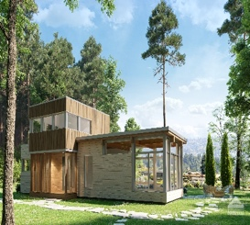
Micro-LoftTM Model Home by Bonneville
Like every home in the Micro-LoftTM series, Alti is all about making the most of every inch of space. The cathedral ceiling, floating stairs and suspended walkway deliver the ultimate in zen-like serenity, making this home a truly unique showpiece. Alti features 1,232 square feet of living space (16’/55’ x 16’/22’), with two bedrooms, a bathroom, a spacious kitchen and plenty of storage. A lunch counter–style table for five is incorporated into the kitchen island. The roomy entrance has a seating area and a large closet. And the covered front porch is an ideal place to stow away seasonal items.

