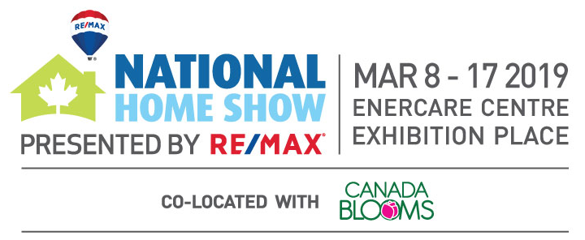

Dear XXXX,

Your complimentary RE/MAX VIP tickets to the National Home Show presented by RE/MAX are enclosed. Beat the line at the Dream Home, get front row seats at the main stage and more! What will inspire you at North America’s largest display of all things home and garden? Whether you’re buying, selling or renting a home the RE/MAX VIP experience at the National Home Show will help you source everything you need to improve your space and maximize your return on investment.
GET CONNECTED WITH SHOW ATTRACTIONS INCLUDING:
SOAK UP SPRING IN CANADA BLOOMS
Spring is just around the corner, get a sneak peek when you tour the expansive gardens of Canada Blooms! Your RE/MAX VIP ticket also grants you access to Canada Blooms. It’s 2 shows, 1 ticket!

RESTYLE YOUR HOME AT DESIGN INTERVENTION
Presented by Reno & Décor Magazine
Take advantage of free expert advice and tips from interior designers during one-on-one consultations! Bring pictures and colour swatches!

DISCOVER NEW TRENDS AT THE UNILOCK CELEBRITY STAGE
So close you can touch the inspiration! RE/MAX VIP ticket holders get front row seats to see celebrity experts on the Unilock Celebrity Stage.
BE INSPIRED BY THE BONNEVILLE DREAM HOME
Hate standing in lines? So do we! Front of the line access to tour the 2019 Dream Home is yet another benefit of your RE/MAX VIP ticket!
Visit www.nationalhomeshow.com for more details.
Produced by:

