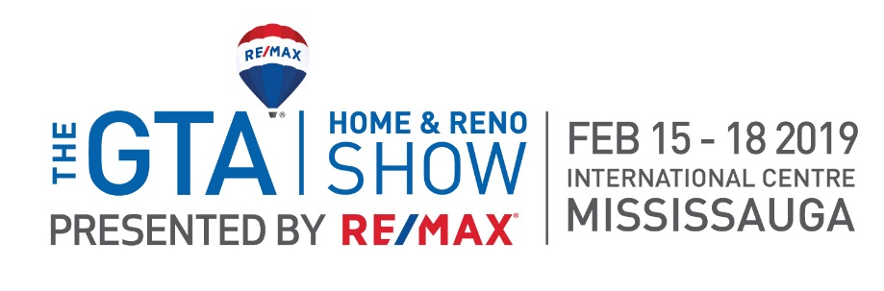

Dear XXXX,

Your complimentary RE/MAX VIP tickets to the GTA Home & Reno Show are enclosed. Whether you’re a renovation rookie or a seasoned DIY’er, the GTA Home & Reno Show can help make your home improvement dreams a reality! Get personalized advice from industry professionals, get hands-on during tool workshops and learn how to add value to your home from some of the most trusted names in the business. Everything you need to get your next project started is waiting for you at the Show!
GET CONNECTED WITH SHOW ATTRACTIONS INCLUDING:
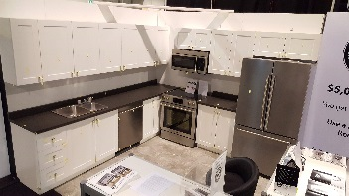
EXPLORE THE $5K KITCHEN
Presented by RenoMark
Thinking about a kitchen reno? Cheaper isn’t always better! Discover what can go wrong and how to avoid it in this underwhelming kitchen.
GET TIPS IN HANDYMAN’S CORNER
Have a few projects to cross off your to-do list? Not sure how to get started? Fear not as Canada’s Handyman is here to demonstrate how to start and more importantly, finish, some of those pesky tasks.
BE INSPIRED BY EXPERTS
Want to know the latest trends? How about the 2019 colour of the year? Get the inspiration and information you need to maximize your project from the comfort of your reserved front row RE/MAX VIP seats!

TOUR THE BoNNEVILLE FEATURE HOME
Hate standing in lines? So do we! Front of the line access to tour the 2019 Feature Home, the “Héméra” built by Bonneville Homes, is yet another benefit of your RE/MAX VIP ticket!

Visit www.gtahomeandrenoshow.com for more details.
Produced by:

